**TUGAS 01**

**INSTALASI FLUTTER ENVIRONMENT**



Pemrograman Berbasis Web - A

Nama :

Adelia Nurlina Putri 4521210059

**PROGRAM STUDI S1 TEKNIK INFORMATIKA**

**FAKULTAS TEKNIK**

**UNIVERSITAS PANCASILA**

**JAKARTA**

**2024**

1. **Instalasi Flutter SDK**
2. Akses web <https://docs.flutter.dev/get-started/install>
3. Pilih OS yang digunakan untuk penggunaan Flutter : macOS

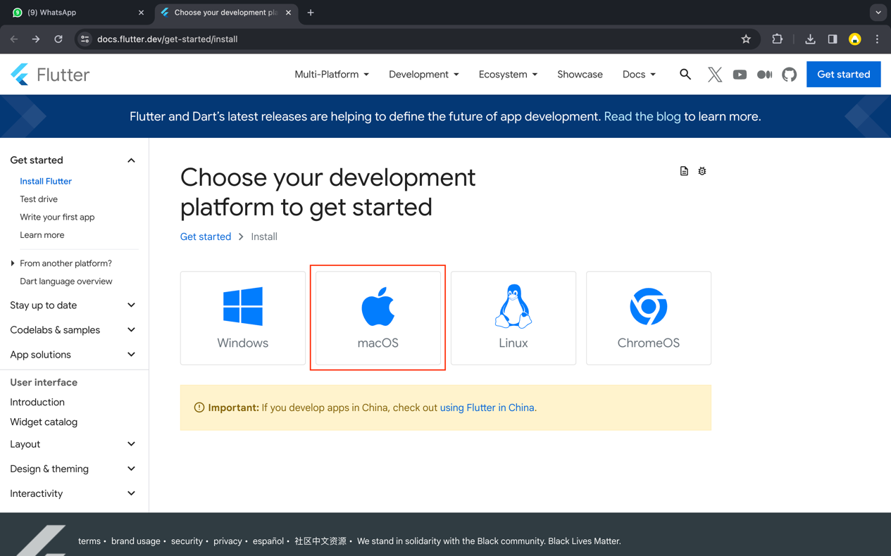

1. Pilih tipe App : Android

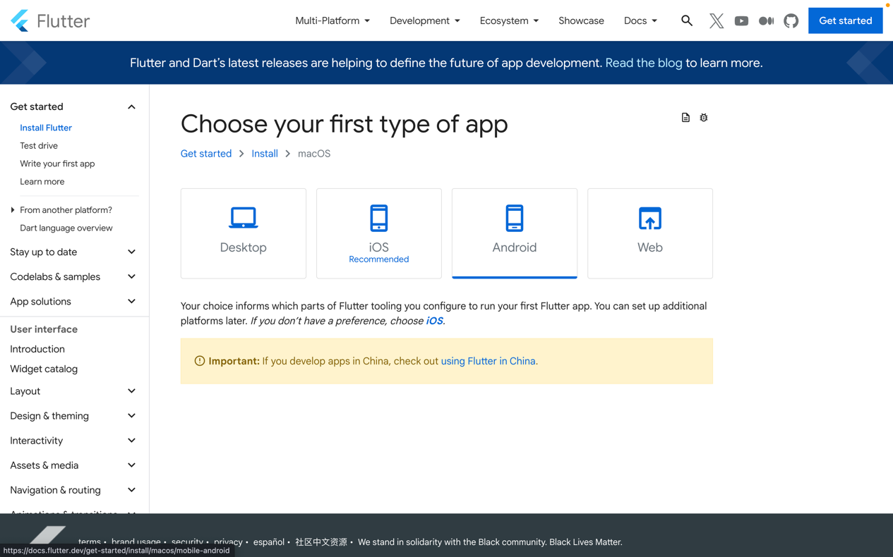

1. Cek default shell (Flutter support MacOS Catalina default shell menggunakan zsh)

|  |
| --- |
| dscl . -read ~/ UserShell |

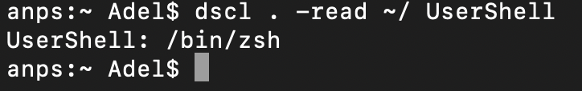

1. Beberapa komponen Flutter memerlukan proses Rosetta 2 di Mac Apple Silicon. Untuk menjalankan semua komponen Flutter di Apple Sillicon, maka perlu instal Rosetta 2.

|  |
| --- |
| sudo softwareupdate --install-rosetta --agree-to-license |

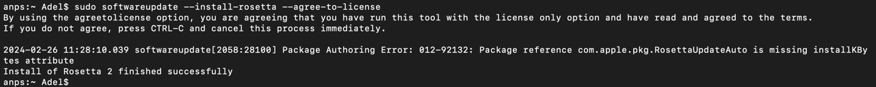

1. Download & Install Visual Studio Code (Installed)
2. Install Flutter Extension

|  |
| --- |
| Buka VSCode -> Marketplace -> Ketik Flutter -> Install |

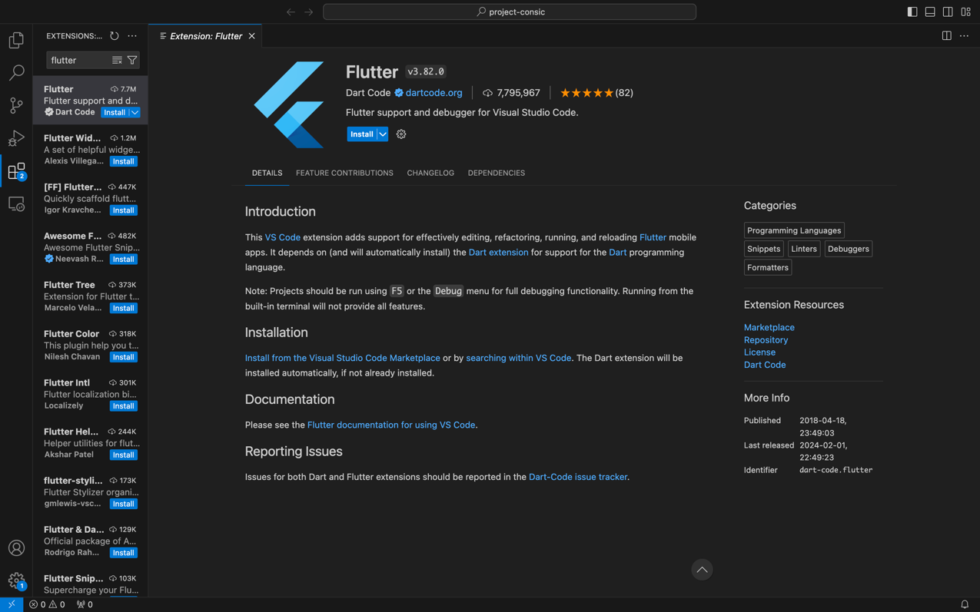

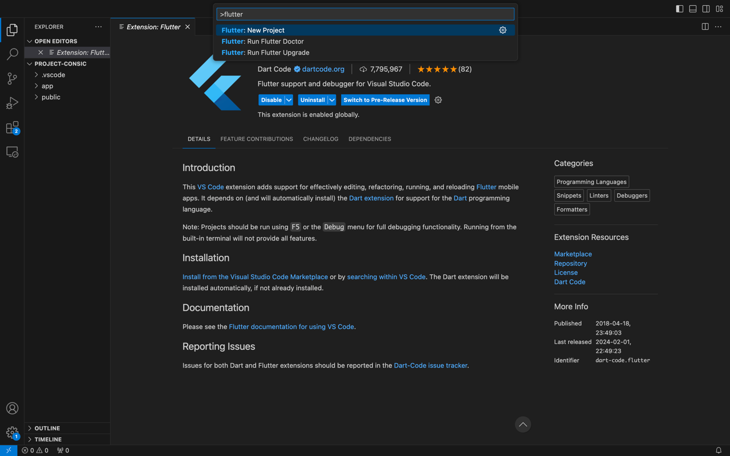

1. Install Flutter SDK

|  |
| --- |
| Buka VSCode -> Command+Shift+P -> Ketik Flutter -> Pilih Flutter: New Project |

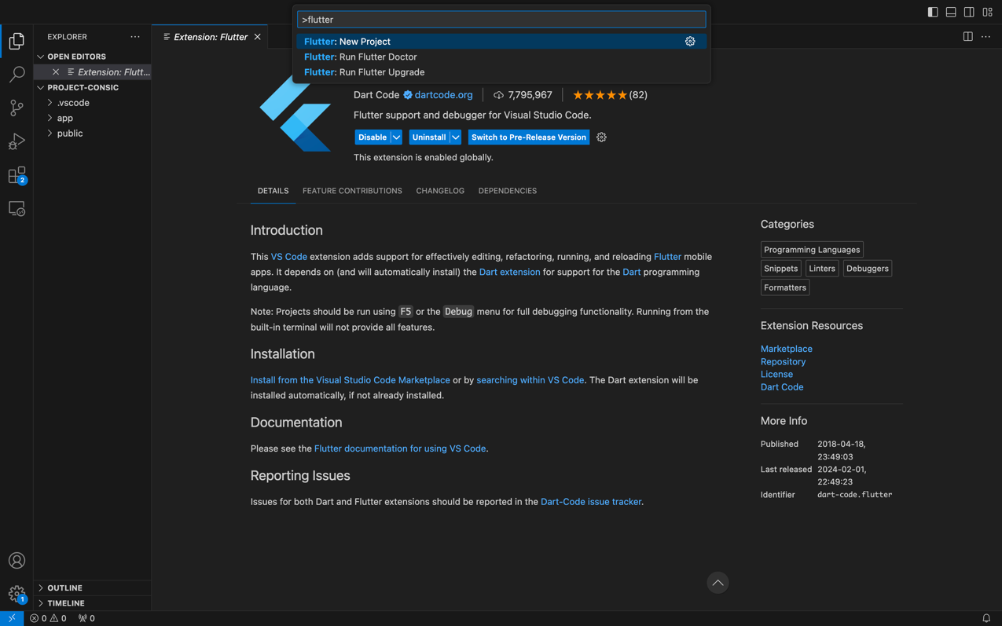

1. Pilih Download SDK

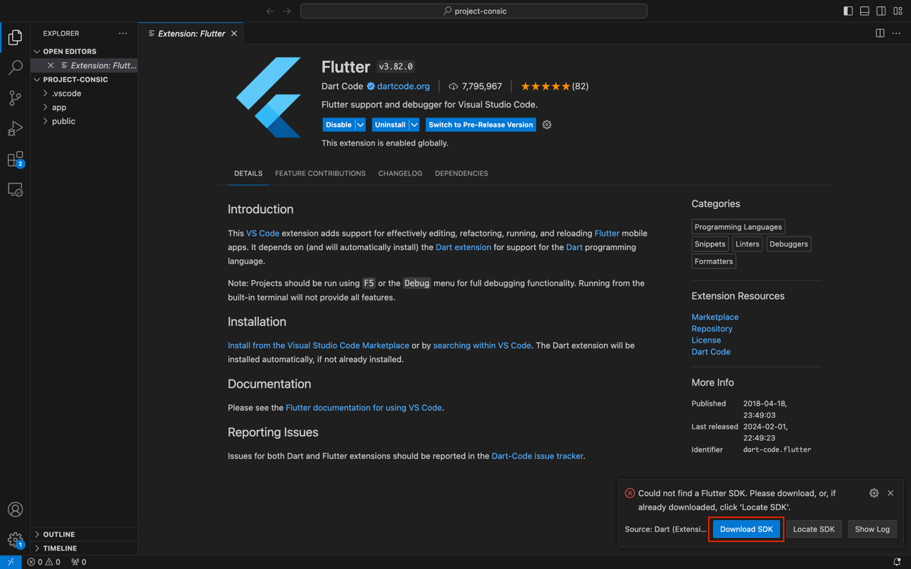

1. Pilih tempat untuk menyimpan file SDK

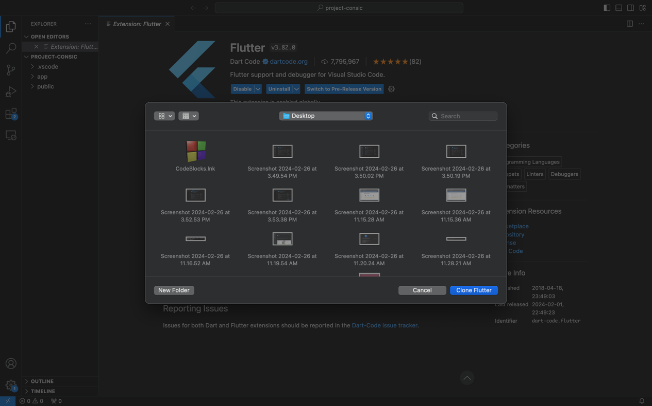

1. Downloading dan Initializing proses

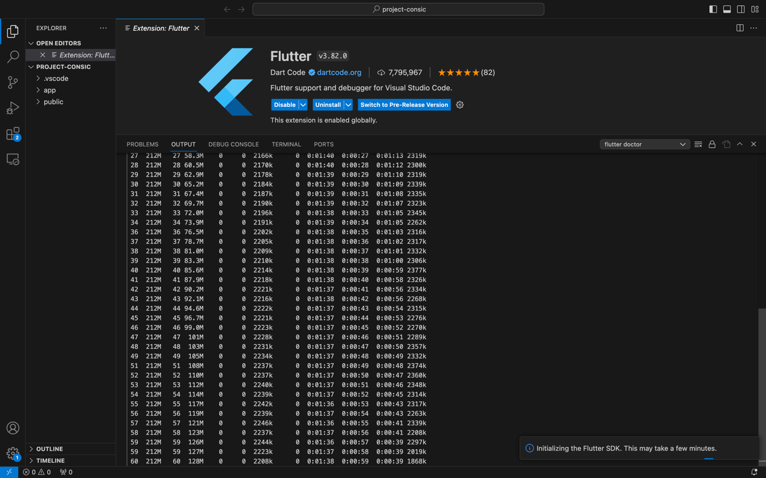

1. Mengaktifkan Flutter pada seluruh terminal

|  |
| --- |
| sudo nano ~/.zshrc  ---  export PATH="$PATH:/Users/Adel/Desktop/flutter/bin"  ---  echo $ PATH |



1. **Instalasi dan Setup Android Studio**
2. Akses web <https://developer.android.com/studio> untuk download Android Studio

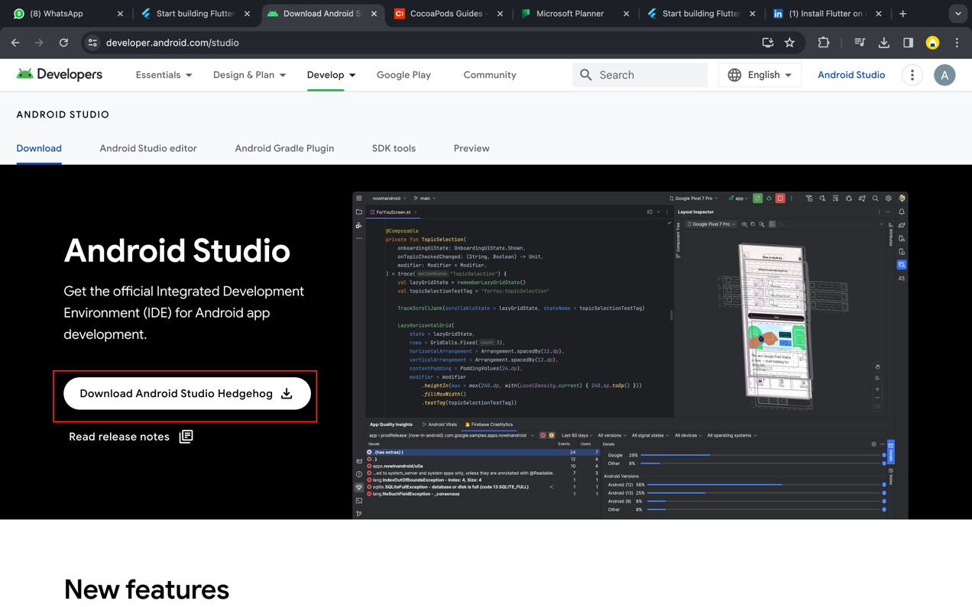

1. Ceklis T&C dan pilih “Mac with Apple Chip” maka download akan dimulai

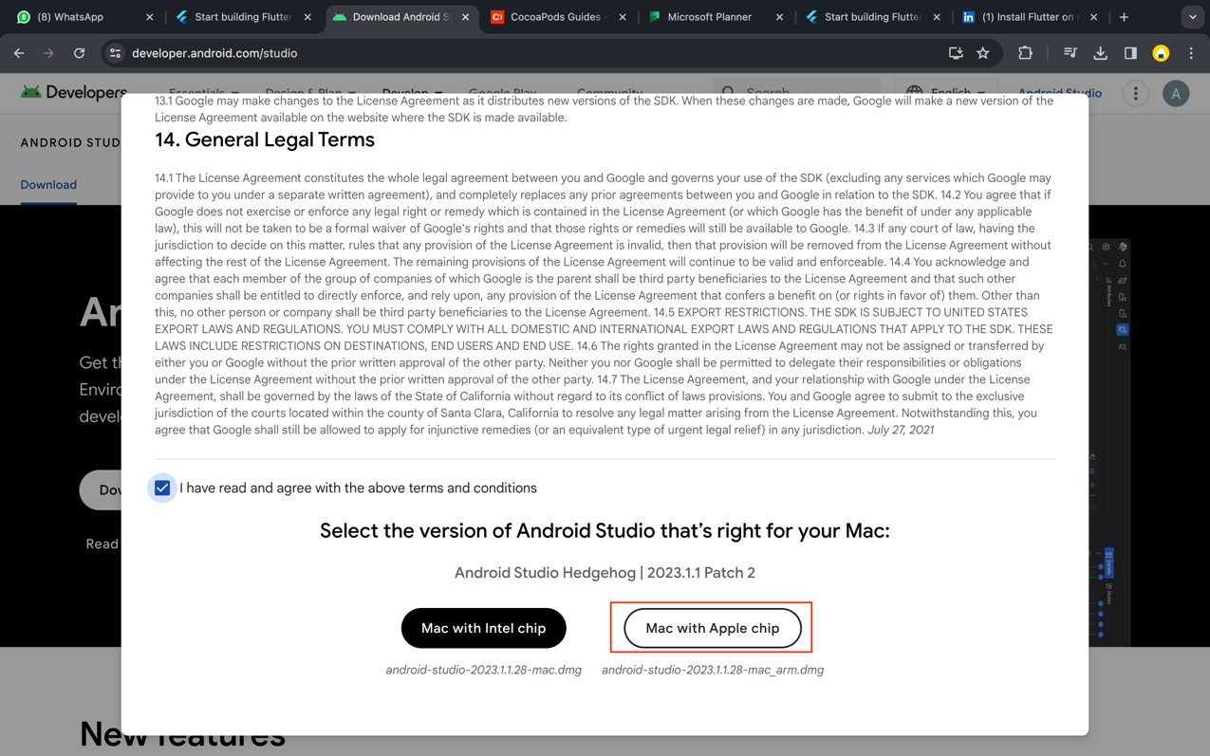

1. Setelah download selesai, klik file .dmg lalu drag & drop icon ke folder Applications

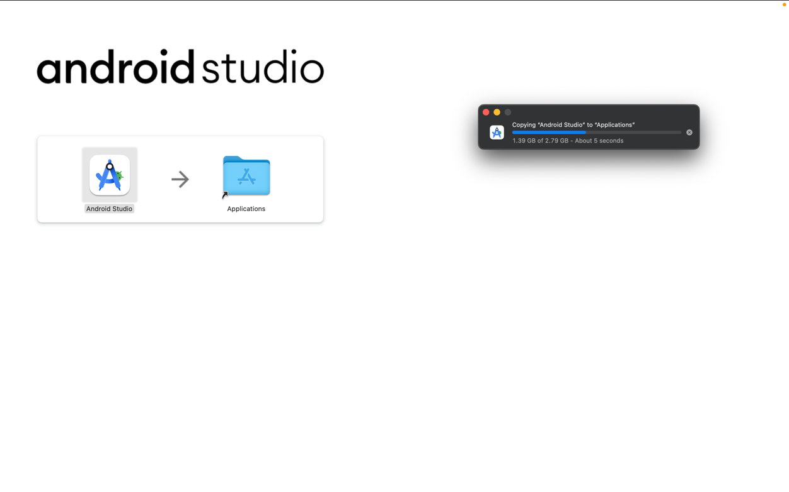

1. Tampilan Android Studio untuk memulai instalasi, klik “Next”

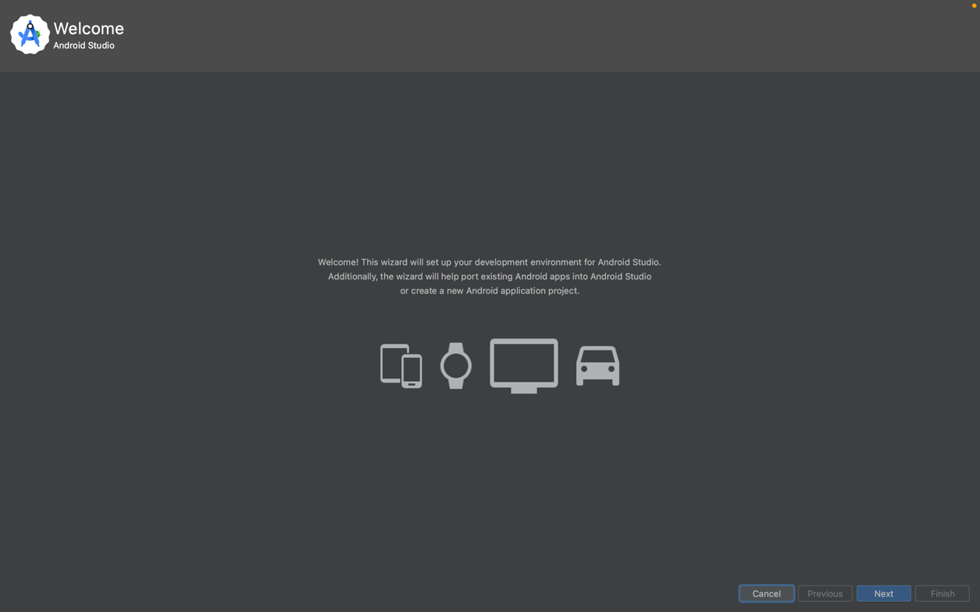

1. Pilih “Standard”

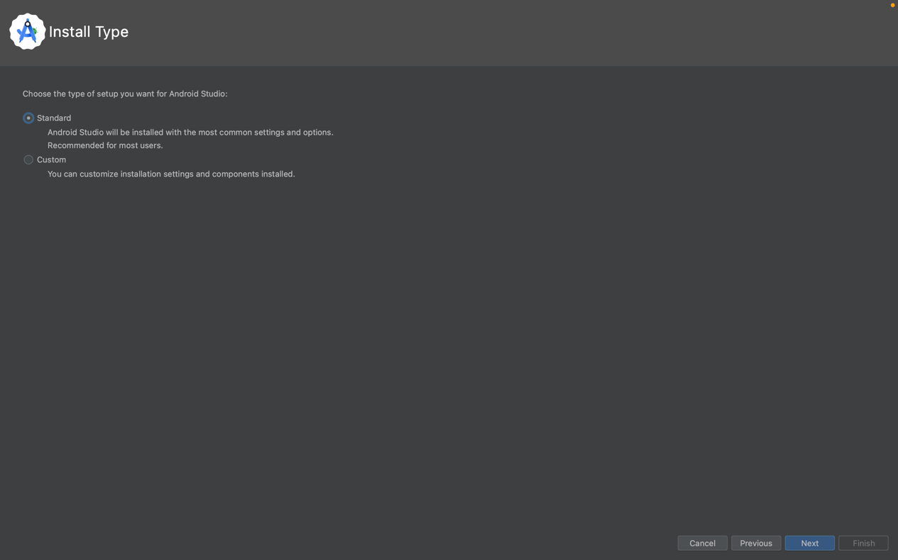

1. Klik “Next”

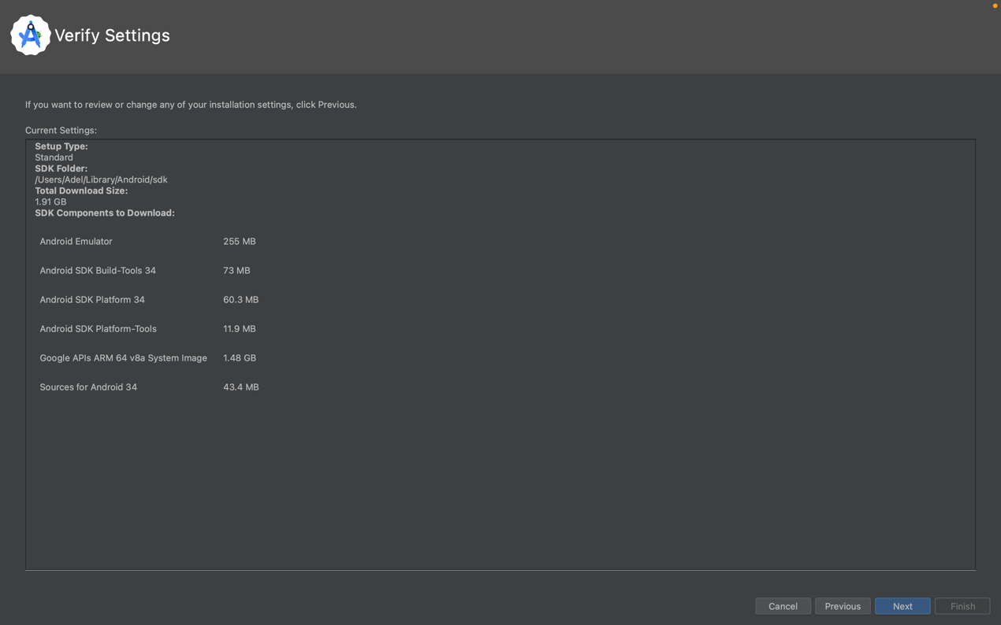

1. Klik “Accept”

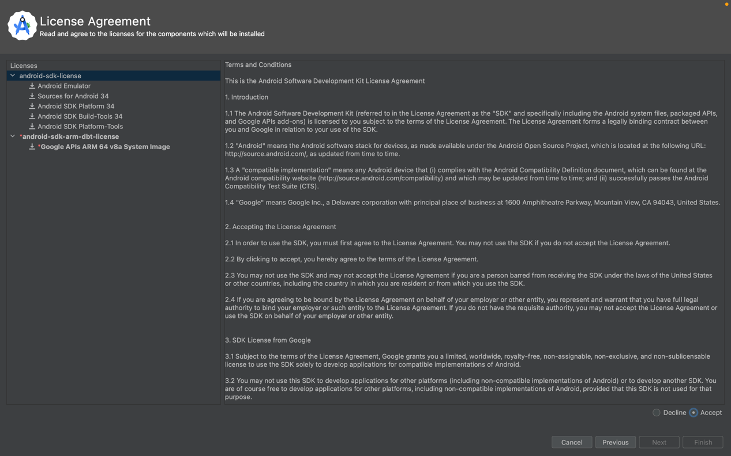

1. Klik “Accept” lalu Next

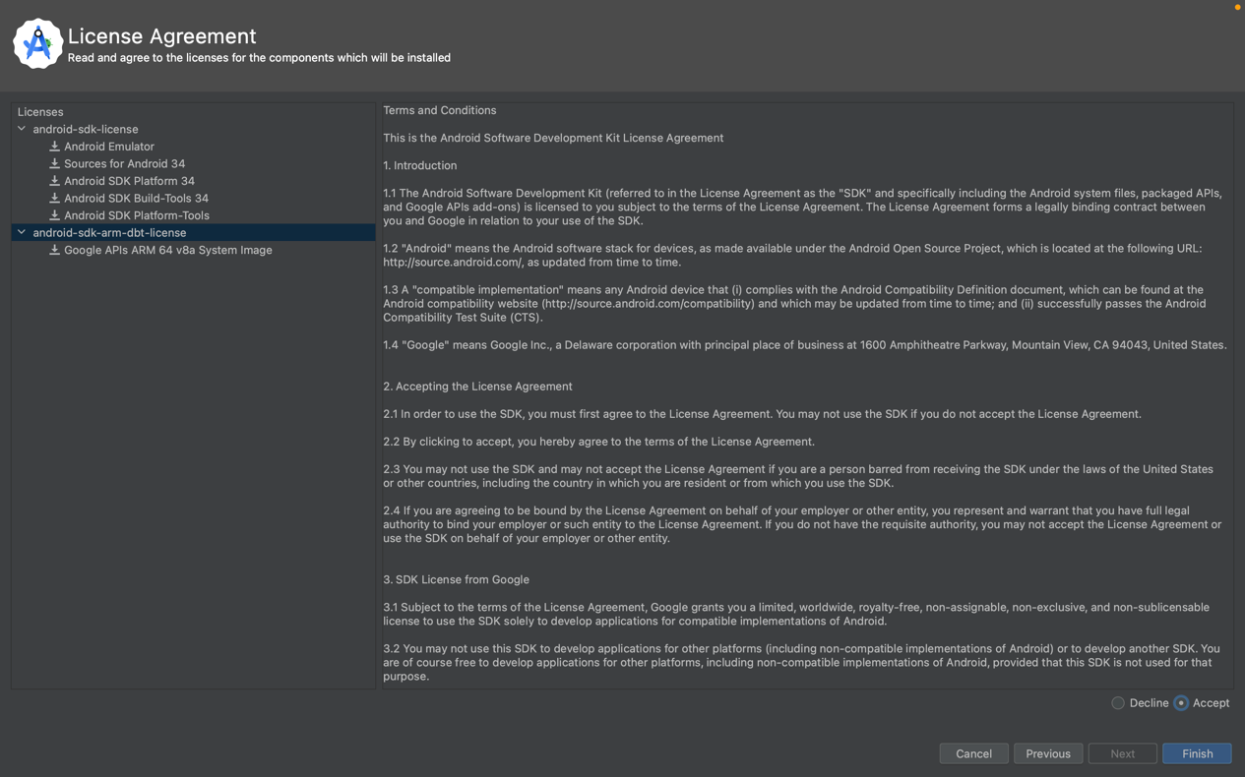

1. Tunggu hingga proses download tools selesai

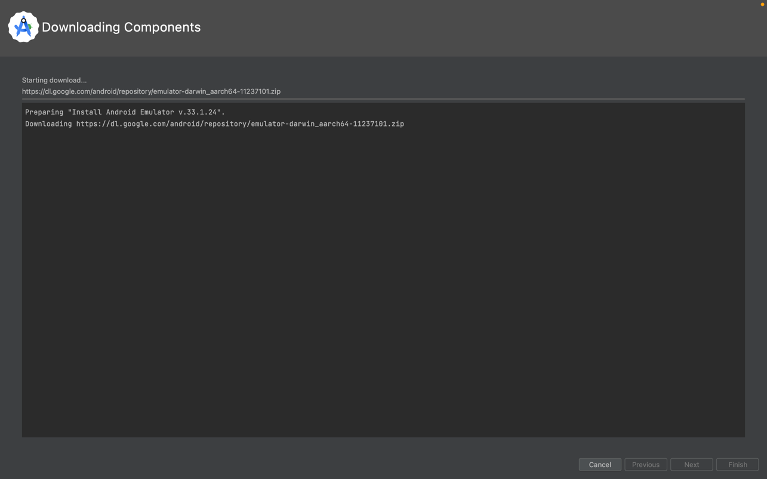

1. Finish

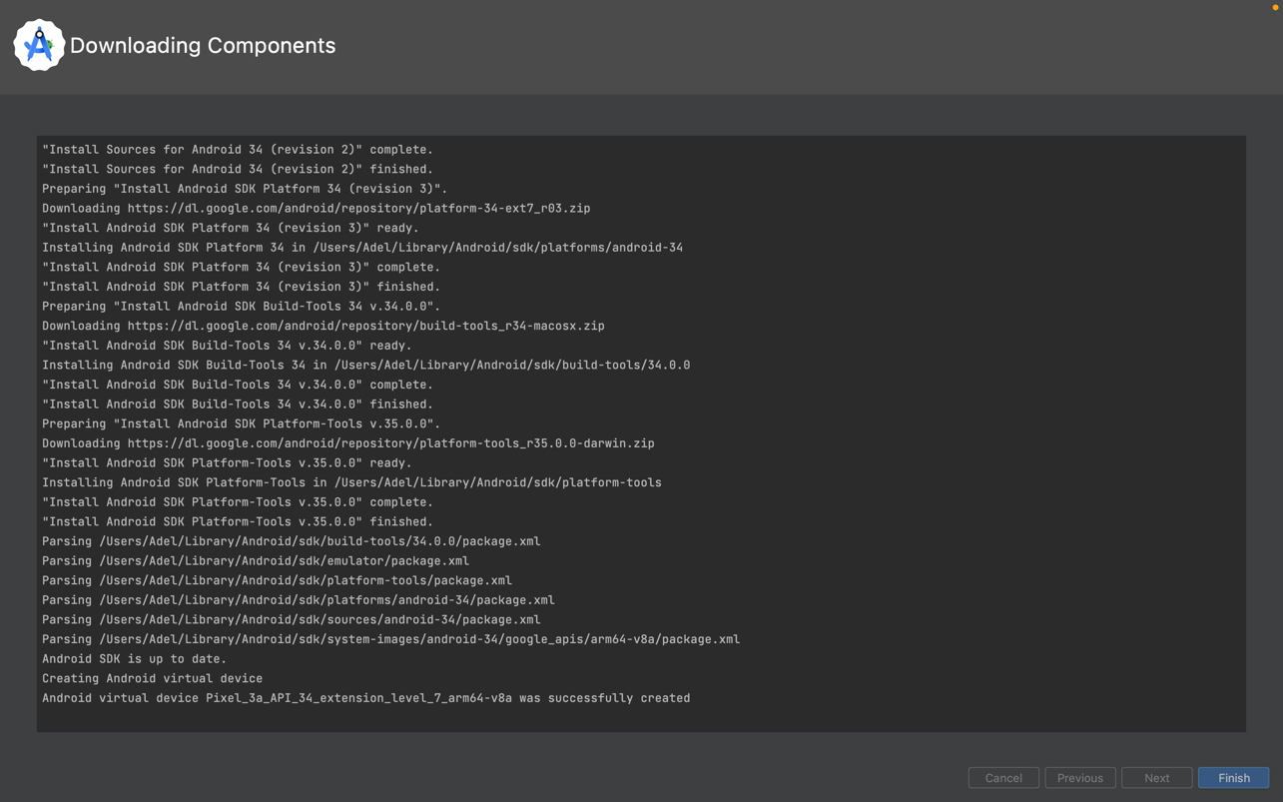

1. Install Android Studio Command-Line Tools

|  |
| --- |
| More Action -> SDK Manager |

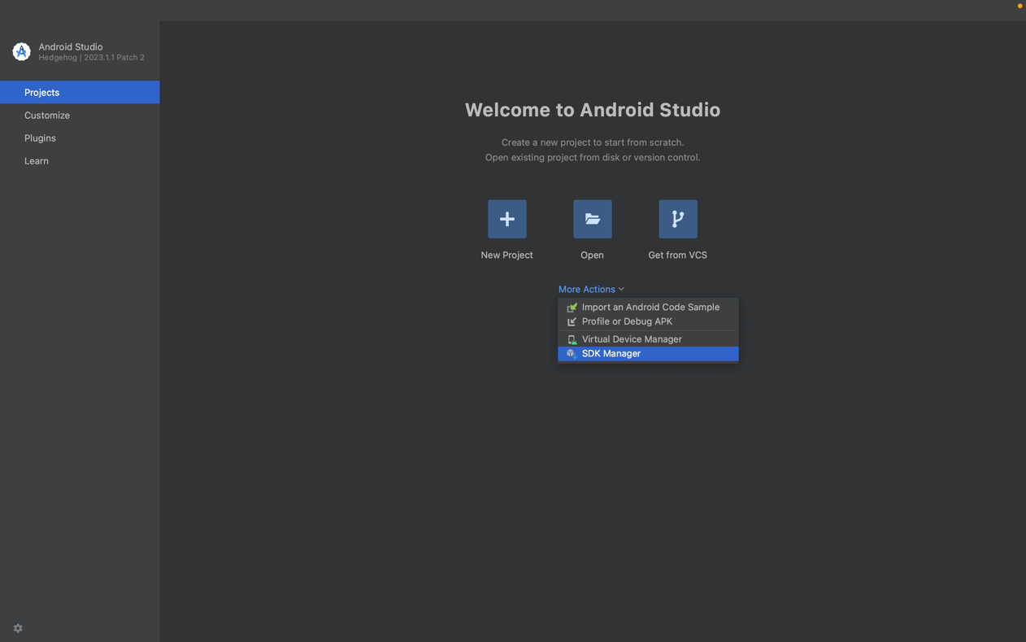

|  |
| --- |
| SDK Tools -> Checklist Android SDK Command-line Tools -> OK |

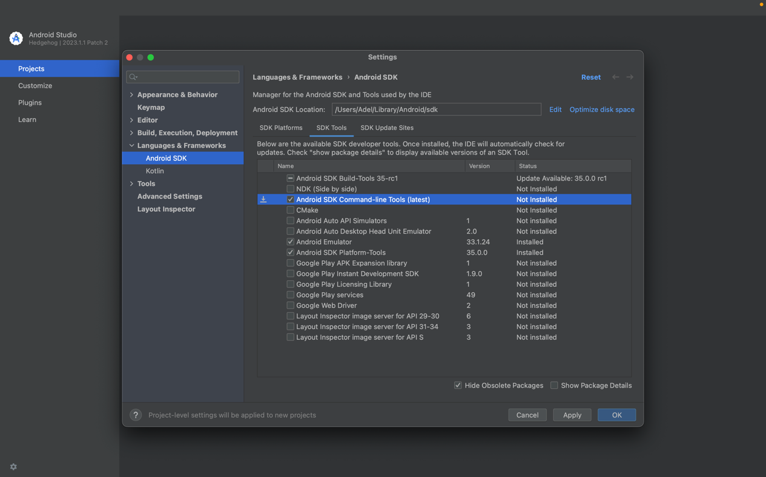

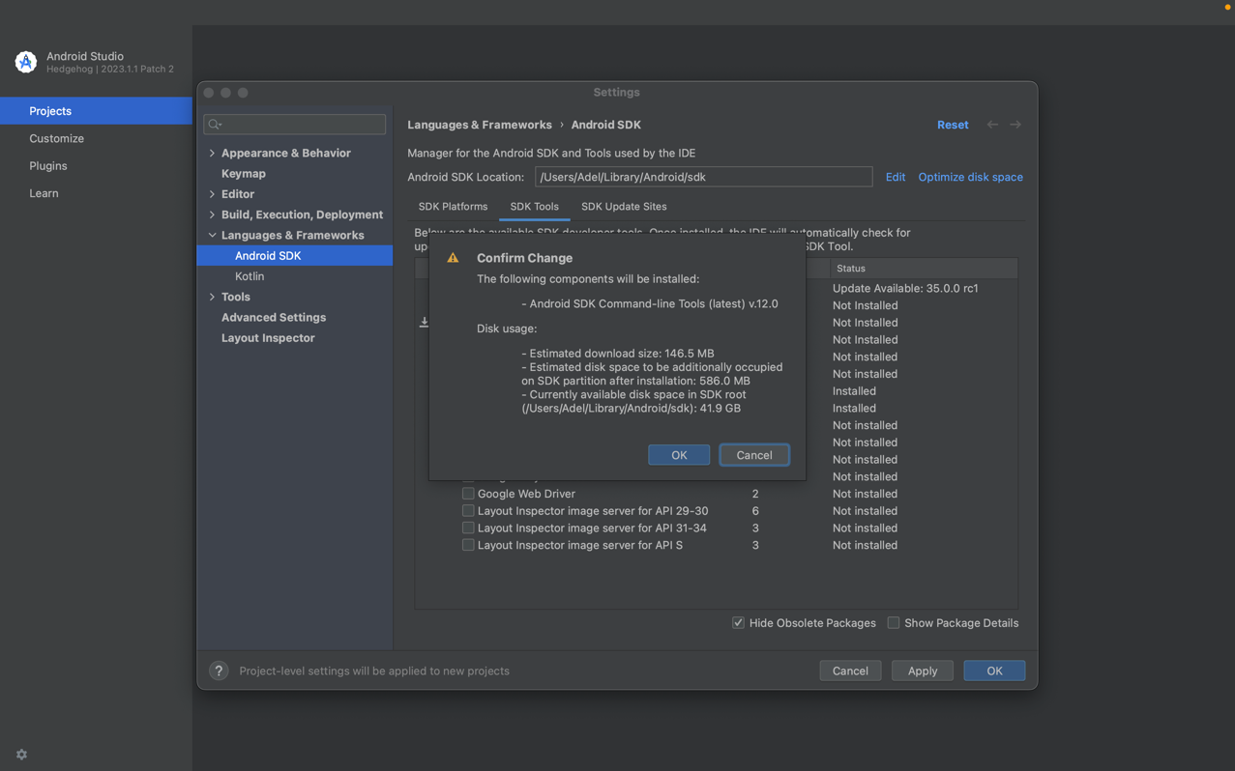

1. Tunggu hingga proses selesai

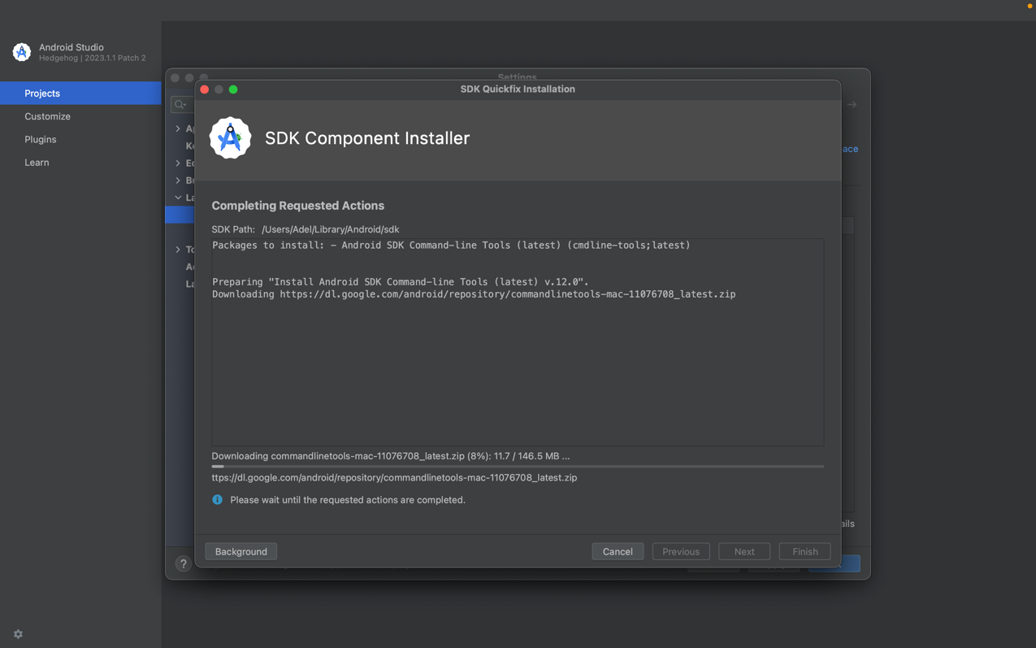

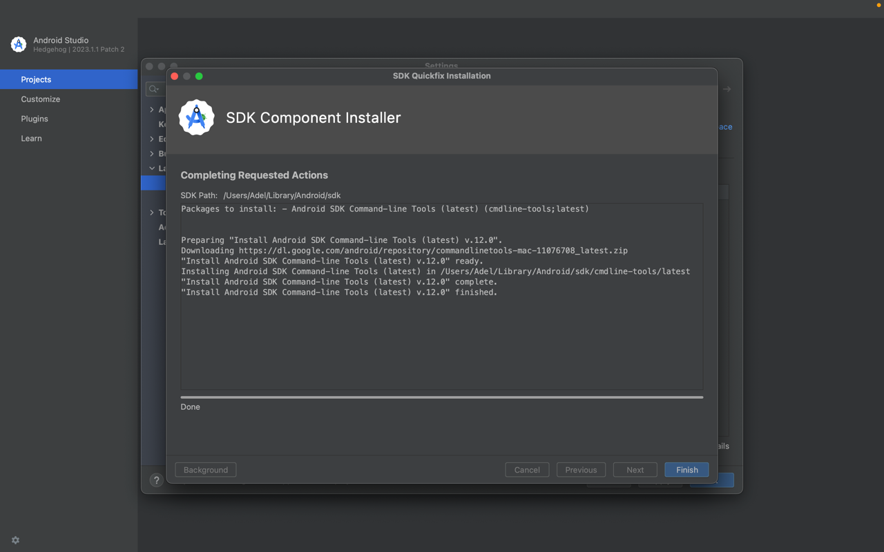

1. Menyetujui Lisensi Android Studio

|  |
| --- |
| $ flutter doctor --android-licenses |

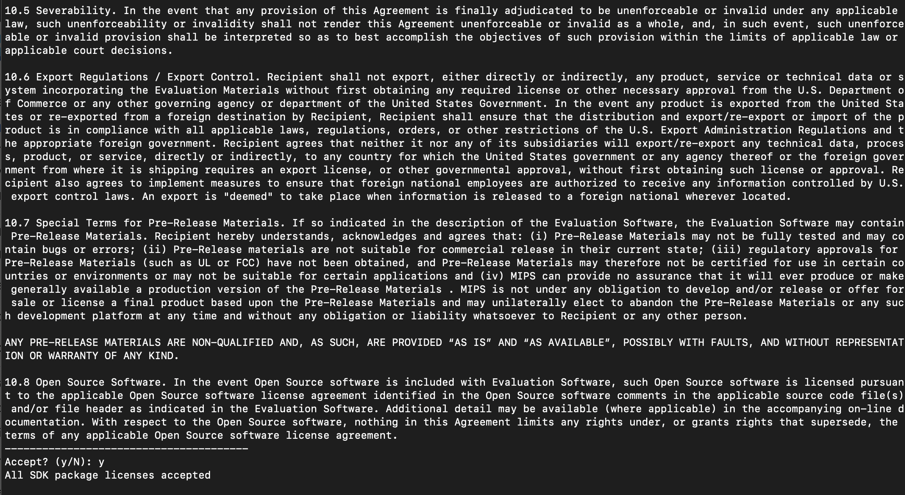

1. **Test Run App Android Studio**
2. Buka Android Studio

|  |
| --- |
| More options -> Virtual Device Manager |

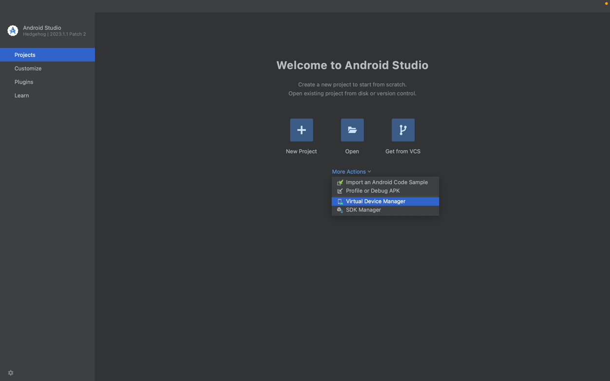

1. Create Virtual Device

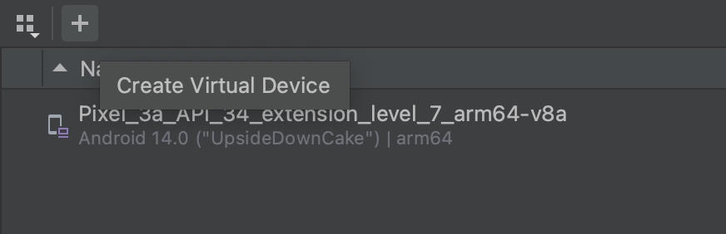

1. Pilih Hardware -> Next

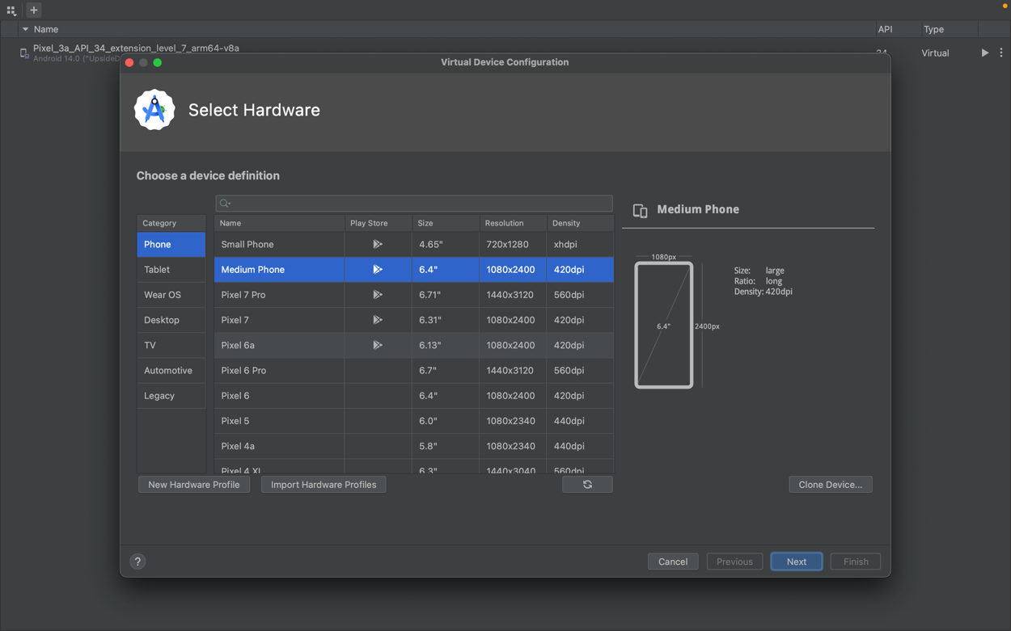

1. Pilih System Image -> Next

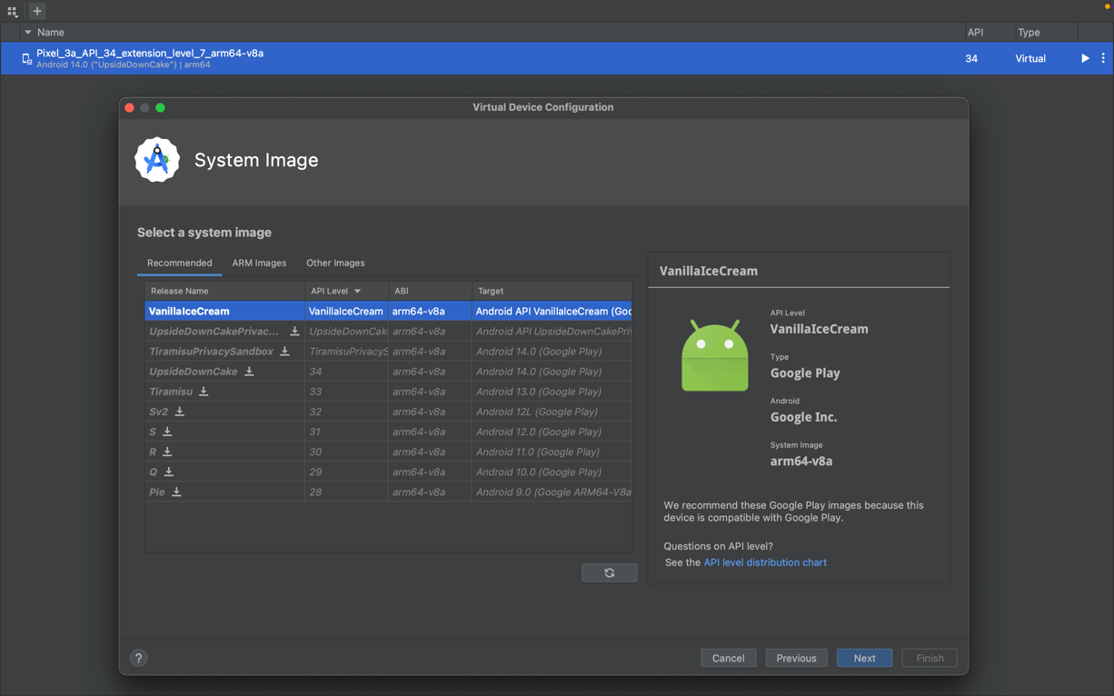

1. Verifikasi konfigurasi -> Finish

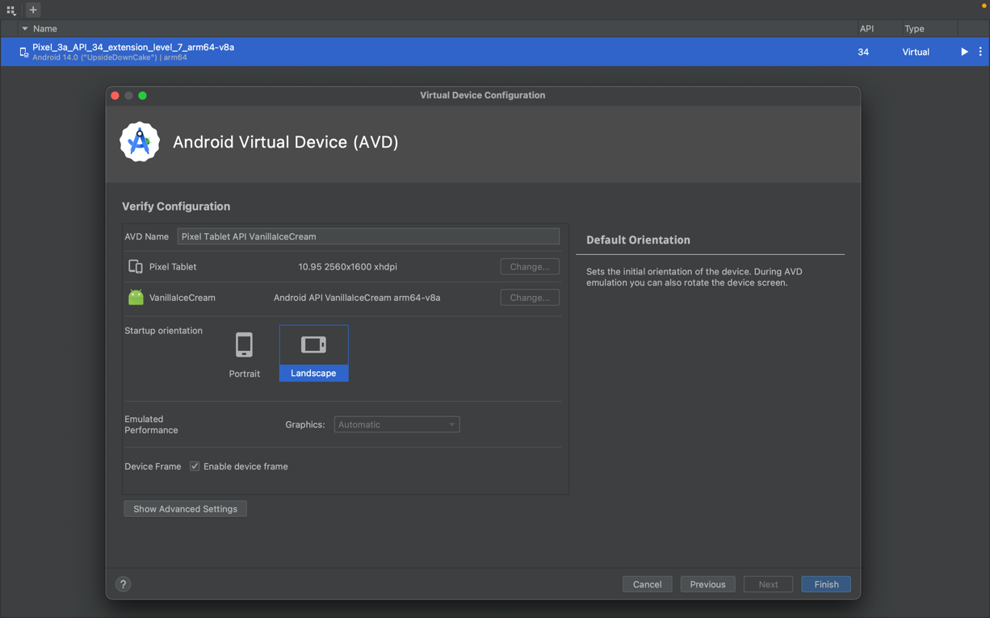

1. Pilih Hardware, kemudian klik icon Run

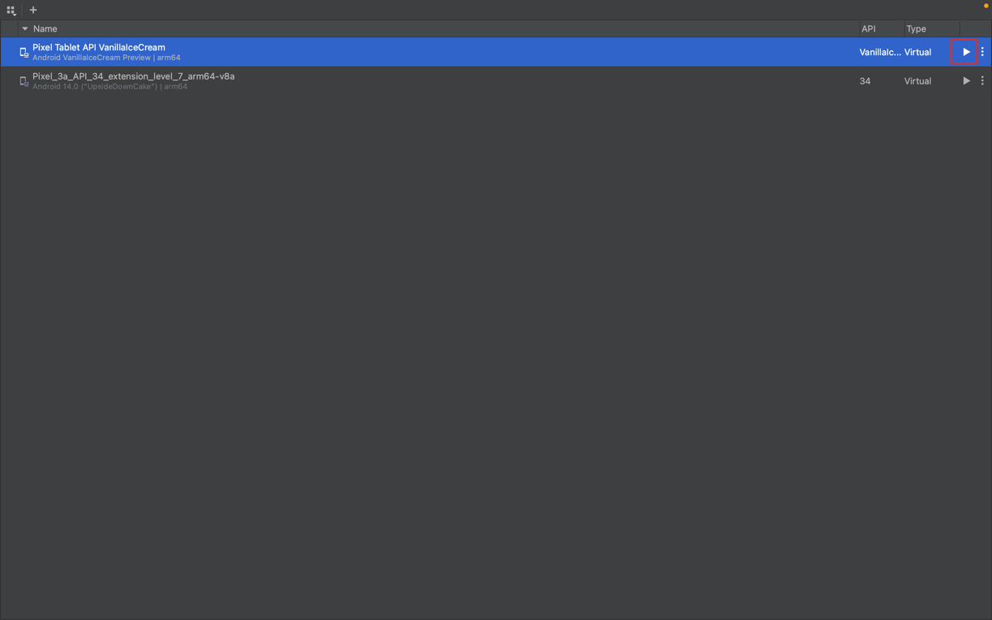

1. Tampilan App

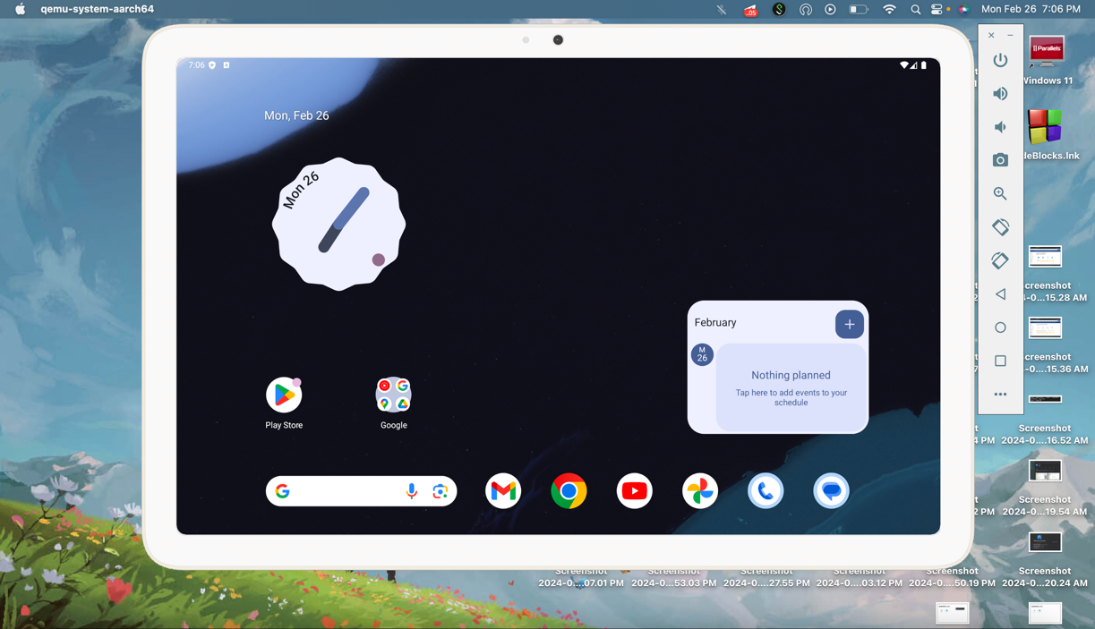

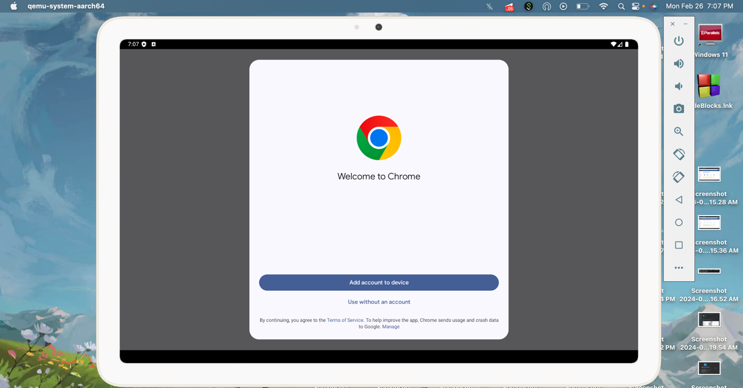

1. **Validasi Komponen Flutter**

|  |
| --- |
| $ flutter doctor |

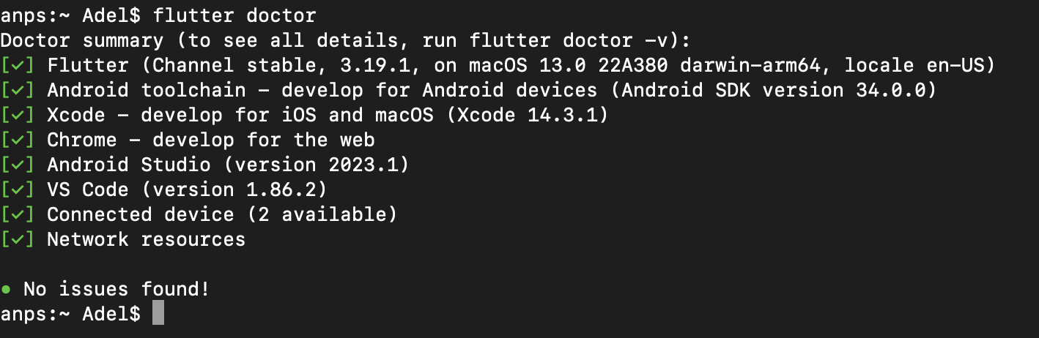

1. **Referensi**

* <https://docs.flutter.dev/get-started/install/macos/mobile-android?tab=virtual>
* <https://marketplace.visualstudio.com/items?itemName=Dart-Code.flutter>
* <https://docs.flutter.dev/get-started/install/macos/mobile-android?tab=virtual>
* <https://docs.flutter.dev/get-started/install/macos/mobile-ios>
* <https://developer.android.com/studio/install>
* <https://www.codewithhussain.com/flutter-cmdline-tools-component-is-missing>